ERP - Distributed Fence Monitor

A Embry-Riddle Aeronautical University project.

FULL DOCUMENT



| **Function** | **By** | **Date** | **Sign** |
| --- | --- | --- | --- |
| Author | Lucas Marin |  |  |

Index

1 Terminology used in the document 4

2 Project overview 5

3 Document Info 6

4 Units 7

5 Reference and applicable documents 8

6 Setups 9

7 Functional Tests 10

8 Correlation Between Functional Tests and Setups 17

9 Testing Laboratory Summary 18

10 List of test document used in this document 19

11 Safety Risk for test described in this document 20

12 Test interruption for environmental test methods 21

13 System of Units and Numeric Convention Used in this Document 22

14 Environmental Qualification Form 23

15 Section Category Cross Reference 25

16 Test Sequence 26

17 Test requirement for unit Node_1 Erp_Distributed_Fence_Monitor_Node_1_2023-04-07 27

Figure index

Figure 1 9

Figure 2 10

Figure 3 11

Figure 4 14

Figure 5 29

# **Terminology used in the document**

| **Applicable Documents** | Applicable documents are those specification, standards, criteria etc. used to define the requirement |
| --- | --- |
| **EQF** | Environmental Qualification Form |
| **Equipment** | The term “equipment” includes the Units and all of the components necessary (as determined by the equipment manufacturer) for the equipment to properly perform its intended function(s). |
| **Estimated stabilization time** | Is the time required by the unit to change (in his biggest inertia part) the temperature from Maximum Storage Temperature to Minimum Storage Temperature after a long storage at high temperature. |
| **EUT** | Equipment Under Test |
| **Reference Documents** | Reference Documents are those documents included for information purpose; they provide insight into the operation, characteristics and interfaces, as well as relevant background information |
| **Sample** | Is a part of an Unit |
| **Sample Group** | Is a set of samples, composed by two or more samples |
| **TBD** | To Be Defined |
| **Unit** | Is the element to be qualified |
| **Unit Group** | Is a set of units, composed by two or more units |
| **UUT** | Unit Under Test, is the unit (or Sample, or Unit Group or Sample Group) that is subjected to tests |

# **Project overview**

## **Project description**

Our capstone team, ERP - Distributed Fence Monitor, is designing and building a module that attaches to a fence and, when it detects vibrations, sends an alert and the appropriate response can be taken.

## **Environments for project**

The product will be used in the following environments:

* Other/Unknown;

## **Aircraft Type**

* Unknown

## **Number of tests**

The total number of test described in this document is: 1

## **Number of UUT**

This project has 1 UUT distributed as follows:

| **Units** |
| --- |
| 1 |

# **Document Info**

This Document was compiled by:

* https://app.do160.org Software rev. 1.6.0 of 2022/Jun/27
* Customer data of 2023/Apr/12

| **Ref.** | **Name** | **Type** | **Last Changes** | **Rev** | **Description** |
| --- | --- | --- | --- | --- | --- |
| § 2 | ERP - Distributed Fence Monitor | Project | 2023/Apr/26 | 1.3 |  |
| § 4.1 | Erp_Distributed_Fence_Monitor_Node_1_2023-04-07 | Unit | 2023/Apr/12 | 1.2 |  |
| § 5.1 | RTCA DO 357:2014 User Guide Supplement To Do-160G | Reference Document | 2023/Apr/07 | 1.0 |  |
| § 5.2 | Standard DO160 | Applicable Document | 2023/Apr/07 | 1.0 |  |
| § 6.1 | Power_Supply_Setup01 | Setup | 2023/Apr/11 | 1.4 |  |
| § 7.1 | Board_Test_01 | Functional Test | 2023/Apr/10 | 1.6 |  |
| § 7.2 | Case_Test_01 | Functional Test | 2023/Apr/11 | 1.7 |  |
| § 7.3 | Case_Test_02 | Functional Test | 2023/Apr/07 | 1.1 |  |
| § 7.4 | Board_Test_03 | Functional Test | 2023/Apr/10 | 1.4 |  |
| § 7.5 | Battery_Test_01 | Functional Test | 2023/Apr/10 | 1.4 |  |
| § 7.6 | Battery_Test_02 | Functional Test | 2023/Apr/07 | 1.1 |  |
| § 7.7 | Board_Test_02 | Functional Test | 2023/Apr/10 | 1.1 |  |
| § 12 | Test interruption for environmental test methods | Page | 2023/Apr/07 | 1.0 |  |
| § 13 | System of Units and Numeric Convention Used in this Document | Page | 2023/Apr/07 | 1.0 |  |
| § 17.1 | Temperature Variation (Sec.5 - Temperature Variation 001) | Test | 2023/Apr/12 | 1.5 |  |

# **Units**

## **Erp_Distributed_Fence_Monitor_Node_1_2023-04-07**

**Part number:** Node_1

### **Weight**

| **Unit** | **Weight** |
| --- | --- |
| **Kilograms** | 0.23 |
| **Pounds** | 0.51 |

### **Sizes**

| **Unit** | **Width** | **Height** | **Depth** |
| --- | --- | --- | --- |
| **Millimeters** | 11.01 | 37 | 143 |
| **Inches** | 0.43 | 1.46 | 5.63 |

### **Input powers**

| **Name** | **Max Current [A]** | **Special Requirements** |
| --- | --- | --- |
| Other voltage | .128 |  |

### **Details**

**Function Performed:** The node will be placed in the thermal chamber and cycle through different power levels and temperatures. It will be expected to operate normally under the varying conditions.

**Estimated stabilization time:** 1 minute

**Operating Altitude:** 1636 m (5367 ft) (83.17 kPa)

### **Safety Risks**

This chapter contain the list of risk specific for this Unit.

* High Temperatures;

# **Reference and applicable documents**

## **Reference Documents**

Reference Documents are those documents included for information purpose; they provide insight into the operation, characteristics and interfaces, as well as relevant background information.

| **Identification** | **Release** | **Date** | **Description** |
| --- | --- | --- | --- |
| RTCA DO 357:2014 User Guide Supplement To Do-160G | G | 2014-12-16 | The purpose of this document is to provide users of DO-160G additional background information for the associated test procedures and requirements in DO-160G. |

## **Applicable Documents**

Applicable documents are those specification, standards, criteria etc. used to define the requirement.

| **Identification** | **Release** | **Date** | **Description** |
| --- | --- | --- | --- |
| Standard DO160 | G | 2010-12-08 | Standard |

# **Setups**

This chapter describes the setup used to perform functional test.

## **Power_Supply_Setup01 - Power_Supply**

### **Description**

1) Set up the power supply in the thermal test room.  
2)Set the power supply to either 3.3 or 4.2 volts, depending on the test being performed.

### **Instruments used for this setup**

| **Instrument** | **Detail** |
| --- | --- |
| Power Supply |  |

### **Images**

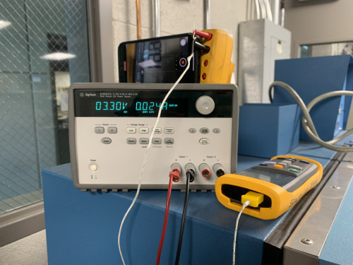

Figure 1

# **Functional Tests**

This chapter describes the functional/operative tests to be performed during testing.

## **Board_Test_01 - Board_Test_01**

### **Test Description**

1. Visually inspect the board for any imperfections.
2. Put the board into the chamber.
3. Attach the thermocouple to the LORA CPU.

### **Pass Conditions**

* No imperfections on the board;

### **Images**

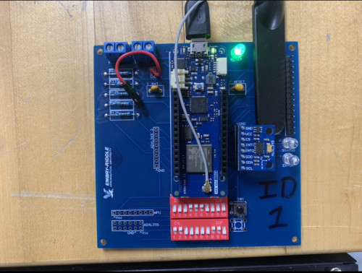

Figure 2

## **Case_Test_01 - Case_Test_01**

### **Test Description**

1. Visually inspect the case for any imperfections, and note them.
2. Put the case into the thermal chamber.

### **Pass Conditions**

* Case is not compromised;

### **Images**

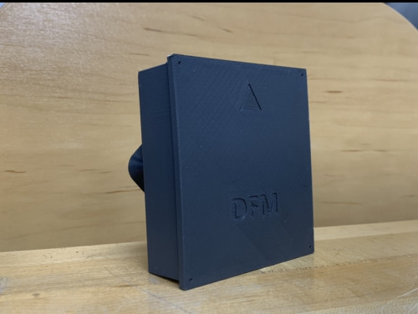

Figure 3

## **Case_Test_02 - Case_Test_02**

### **Test Description**

1. Remove the case from the thermal chamber.
2. Visually inspect the case to check for any imperfections not noted before.

### **Pass Conditions**

* No new imperfections;

### **Operator**

This functional test requires an operator, so it normally cannot be carried on during the night or during weekend.

## **Board_Test_03 - Board_Test_03**

### **Test Description**

1. Visually inspect the board for any imperfections not noted before.

### **Pass Conditions**

* No new imperfections;
* Fail LED is not turned on;
* No reset detected;

## **Battery_Test_01 - Battery_Test_01**

### **Test Description**

1. Measure the voltage of the battery.
2. Put the battery in the thermal chamber.

### **Pass Conditions**

* Battery voltage macthes;

### **Images**

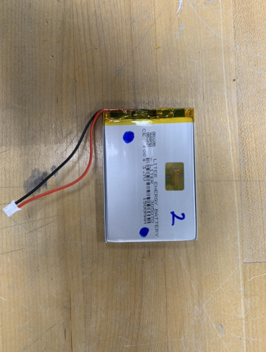

Figure 4

## **Battery_Test_02 - Battery_Test_02**

### **Test Description**

1. Remove the battery from the thermal chamber.
2. Measure the voltage of the battery.
3. Verify it matches the previous measurement.

### **Pass Conditions**

* Battery voltages match;

## **Board_Test_02 - Board_Test_02**

### **Test Description**

1. Run (max power code) to transmit at max power every 5 seconds.

### **Pass Conditions**

* Board cycles through power levels;

# **Correlation Between Functional Tests and Setups**

| **Setup** | **Power_Supply_Setup01** |
| --- | --- |
| **Functional Test** |  |
| **Board_Test_01** |  |
| **Case_Test_01** |  |
| **Case_Test_02** |  |
| **Board_Test_03** |  |
| **Battery_Test_01** |  |
| **Battery_Test_02** |  |
| **Board_Test_02** |  |

# **Testing Laboratory Summary**

This chapter provides information on where each test indicated in this document will be performed.

## **Unit Erp_Distributed_Fence_Monitor_Node_1_2023-04-07**

| **Test (Identification)** | **Ref** | **Laboratory** |
| --- | --- | --- |
| Sec.5 Temperature Variation  (Sec.5 - Temperature Variation 001) | 17.1 | Not Defined |

# **List of test document used in this document**

This chapter contain a cross reference between each test and used documentation.

|  | **Test** | **§17.1** |
| --- | --- | --- |
|  | **DO160 G Section** | **5** |
| **Document** | **Section** |  |
| **Standard DO160** | **5** | **X** |
| **RTCA DO 357:2014 User Guide Supplement To Do-160G** | **5** | **X** |

# **Safety Risk for test described in this document**

The Test indicated in this document can be dangerous for person, or can spride risk. In this chapter a list of risk for each test is described.

| **Test** | **§17.1** |
| --- | --- |
| **DO160 G Section** | **5** |
| **Risk** |  |
| **Danger of very low temperatures** | **X** |
| **Danger of High Temperature** | **X** |

# **Test interruption for environmental test methods**

The following procedures shall be followed when a test is interrupted. Explain test interruptions in the test report, and any deviation from the following information.

1. ***In-tolerance interruptions***  
   Interruption periods during which the prescribed test tolelrances (e.g. power interruptions that do not affect chamber temperature) do not constitute a test interruption. Therefore, do not modify the test duration if exposure to proper test levels was maintained during the ancillary interruption.
2. ***Out-of-tolerance interruptions***
   * ***Undertest***  
     If test tolerances have been exceed resulting in an under test condition, the test may be resumed from the point at which tolerances were exceed following reestablishment of prescribed conditions (except as noted in the individual methods), and extended to insure that the prescribed test cycle is achieved by the test laboratory.
   * ***Overtest***  
     If the overtest was occurred, the test will be stopped during the test according to customer's chosen, and will be conducted an a functional checks according to § 7. if the functional checks results are compliant with the § 7, re start the test, otherwise the test will be performed with a new test article.  
       
     If any damage is a direct result of the over test conditions and will not affect other EUT characteristics, or if the EUT can be repaired, the test may be resumed and extended as in the under test condition.  
       
     If an item failure occurs during the remainder of the test, the test result shall be considered invalid.  
       
     For the ambient measurement into electromagnetics environments, the ambient electromagnetic level measured with the EUT de-energized and all auxiliary equipment turned on shall be at least 6 dB below the allowable specified limits when the tests are performed in a shielded enclosure.
3. ***Other environmental test methods set out in the document***  
   Each of these methods contains guidance for handling out-of-tolerance-test interruption. Any such interruption must be carefully analysed. If the decision is made to continue testing from the point interruption, to restart the last successfully completed test cycle, or to restart the entire test with the same EUT, and a failure occurs, it is essential to consider the possibility effect of the interruption or of the extended length of the test

# **System of Units and Numeric Convention Used in this Document**

Numbers where defined using a dot: (For example 1/3= 0.333333333)

Thousands where defined with space. (For example  1 000 000)

The following units where used

* **s** - Seconds
* **m** - Meters
* **kg** - Kilograms
* **Pa** - Pascal
* **F** - Farad
* **C** - Coloumb
* **A** - Ampere
* **V** - Volt
* **J** - Joule
* **N** - Newton
* **H** - Henry
* **T** - Tesla
* **w** - Weber
* **W** - Watt
* **Ohm** - Ohm
* **K** - Kelvin
* **Hz** - Hertz

Factor Scale

* Kilo **(k)** = 1000
* Mega **(M)** = 1 000 000
* Giga **(G)** = 1 000 000 000
* micro **(u)** = 0.000 001
* nano **(n)** = 0.000 000 001
* pico **(p)** = 0.000 000 000 001

DATES FORMAT **YYYY-MM-DD**

# **Environmental Qualification Form**

## **EQF for Erp_Distributed_Fence_Monitor_Node_1_2023-04-07**

| **NOMENCLATURE** | Erp_Distributed_Fence_Monitor_Node_1_2023-04-07 |
| --- | --- |
| **TYPE/MODEL/PART NO** | Node_1 |
| **TSO NUMBER** | __________________________________________ |
| **MANUFACTURER'S SPECIFICATION AND/OR OTHER APPLICABLE SPECIFICATION** | __________________________________________  __________________________________________  __________________________________________  __________________________________________ |
| **MANUFACTURER** | Embry-Riddle Aeronautical University |
| **ADDRESS** | __________________________________________ |
| **REVISION & CHANGE NUMBER OF DO-160** | DO 160 G |
| **DATE TESTED** | __________________________________________ |

| **Conditions** | **Sections** | **Description of tests conducted (Category)** |
| --- | --- | --- |
| DO160G - Temperature and Altitude | Sec.4 | Not performed/Applicable |
| **Temperature Variation** | **Sec.5** | A |
| DO160G - Humidity | Sec.6 | Not performed/Applicable |
| DO160G - Operational Shocks and Crash Safety | Sec.7 | Not performed/Applicable |
| DO160G - Vibration | Sec.8 | Not performed/Applicable |
| DO160G - Explosive Atmosphere | Sec.9 | Not performed/Applicable |
| DO160G - Waterproofness | Sec.10 | Not performed/Applicable |
| DO160G - Fluids Susceptibility | Sec.11 | Not performed/Applicable |
| DO160G - Sand and Dust | Sec.12 | Not performed/Applicable |
| DO160G - Fungus Resistance | Sec.13 | Not performed/Applicable |
| DO160G - Salt Fog | Sec.14 | Not performed/Applicable |
| DO160G - Magnetic Effect | Sec.15 | Not performed/Applicable |
| DO160G - Power Input | Sec.16 | Not performed/Applicable |
| DO160G - Voltage Spike | Sec.17 | Not performed/Applicable |
| DO160G - Audio Frequency Conducted Susceptibility - Power Inputs | Sec.18 | Not performed/Applicable |
| DO160G - Induced Signal Susceptibility | Sec.19 | Not performed/Applicable |
| DO160G - Radio Frequency Susceptibility (Radiated and Conducted) | Sec.20 | Not performed/Applicable |
| DO160G - Emission of Radio Frequency Energy (Radiated and Conducted) | Sec.21 | Not performed/Applicable |
| DO160G - Lightning Induced Transient Susceptibility | Sec.22 | Not performed/Applicable |
| DO160G - Lightning Direct Effects | Sec.23 | Not performed/Applicable |
| DO160G - Icing | Sec.24 | Not performed/Applicable |
| DO160G - Electrostatic Discharge (ESD) | Sec.25 | Not performed/Applicable |
| DO160G - Fire and Flammability | Sec.26 | Not performed/Applicable |

# **Section Category Cross Reference**

This chapter contain information on the environment selected for each test.

## **Environments for Erp_Distributed_Fence_Monitor_Node_1_2023-04-07**

| **Test** | **Sections** | **Description of Environment described in the section** |
| --- | --- | --- |
| **Temperature Variation**  (Sec.5 - Temperature Variation 001) | **Sec.5** | **Category: A -** For equipment external to the aircraft or internal to the aircraft: 10 degrees Celsius minimum per minute. |

# **Test Sequence**

## **Test Sequence for unit "Node_1 Erp_Distributed_Fence_Monitor_Node_1_2023-04-07"**

### **Execute in this order**

| **n.** | **Test Name** | **Section** |
| --- | --- | --- |
| 1 | **Temperature Variation**  Sec.5 - Temperature Variation 001 | Sec.5 |

# **Test requirement for unit Node_1 Erp_Distributed_Fence_Monitor_Node_1_2023-04-07**

## **DO 160 G - Sec.5 - Temperature Variation - "Sec.5 - Temperature Variation 001"**

| **Standard:** | DO160 G |
| --- | --- |
| **Section:** | 5 |
| **Title:** | Temperature Variation |
| **Category:** | A |

### **Purpose of the test**

This test determines performance characteristics of the equipment during temperature variations between high and low operating temperature extremes. **Note:** The test is not intended to verify the behavior of the equipment in wet or icing conditions. In conducting this test, the test chamber may incorporate the capability of controlling or altering humidity to the extent that condensation is minimized or does not occur.

### **Reference Documents**

| **Identification** | **Release** |
| --- | --- |
| RTCA DO 357:2014 User Guide Supplement To Do-160G | G |

### **Applicable Documents**

| **Identification** | **Release** |
| --- | --- |
| Standard DO160 | G |

### **Test Procedure**

**1)** Setup the unit as per [Power_Supply_Setup01 - Power_Supply (§ 6.1)];

**2)** Perform test as per [Board_Test_01 - Board_Test_01 (§ 7.1)];

**3)** Perform test as per [Case_Test_01 - Case_Test_01 (§ 7.2)];

**4)** Perform test as per [Battery_Test_01 - Battery_Test_01 (§ 7.5)];

**5)** Install the EUT in the climatic chamber

**6)** Install the UUT in chamber 2 as for [Board_Test_02 - Board_Test_02] [**ONLY** at cycle (**1**)]

**7)** Start at standard ambient temperature (**22 °C | 54 °F**)

**8)** Decrease the temperature in the chamber towards the operating low temperature level (**0 °C | 32 °F**) at the applicable rates of 4 degrees Celsius minimum per minute)

**9)** Increase the temperature in the chamber towards the operating high temperature level (**50 °C | 82 °F**) at the applicable rates of 4 degrees Celsius minimum per minute)

**10)** Switch off the UUT

**11)** Maintain the equipment in a non-operating state for 2 minutes

**12)** Turn the equipment on

**13)** Lower the temperature in the chamber towards the operating low temperature level (**0 °C | 32 °F**) at the applicable rates of 4 degrees Celsius minimum per minute)

**14)** Perform test [Board_Test_02 - Board_Test_02] [**ONLY** at cycle (**1**)]

**15)** Turn off the equipment

**16)** Wait 30 minutes

**17)** Switch on the UUT as per [Board_Test_02 - Board_Test_02] [**ONLY** at cycle (**1**)]

**18)** Change the temperature of the chamber towards the ambient temperature (**22 °C | 54 °F**) at the applicable rates of 4 degrees Celsius minimum per minute)

**19)** Repeat steps **7)..18)** for another time (**Total** of 2 cycles)

**20)** Perform test as per [Board_Test_03 - Board_Test_03 (§ 7.4)];

**21)** Perform test as per [Case_Test_02 - Case_Test_02 (§ 7.3)];

**22)** Perform test as per [Battery_Test_02 - Battery_Test_02 (§ 7.6)];

### **Test Duration**

Estimated test duration: 1 Day 3 Hours

### **Test Interruption**

Continue with testing

### **Instruments**

* From SETUP "Power_Supply_Setup01 - Power_Supply [§ 6.1]": Power Supply;
* Climatic Chamber;

### **Safety Risks**

* Danger of very low temperatures;
* Danger of High Temperature;

### **Pass conditions**

* [Before TEST] - from (Board_Test_01 - Board_Test_01 [§ 7.1]): No imperfections on the board;
* [Before TEST] - from (Case_Test_01 - Case_Test_01 [§ 7.2]): Case is not compromised;
* [Before TEST] - from (Battery_Test_01 - Battery_Test_01 [§ 7.5]): Battery voltage macthes;
* [During TEST] - from (Board_Test_02 - Board_Test_02 [§ 7.7]): Board cycles through power levels;
* [After TEST] - from (Board_Test_03 - Board_Test_03 [§ 7.4]): No new imperfections;
* [After TEST] - from (Board_Test_03 - Board_Test_03 [§ 7.4]): Fail LED is not turned on;
* [After TEST] - from (Board_Test_03 - Board_Test_03 [§ 7.4]): No reset detected;
* [After TEST] - from (Case_Test_02 - Case_Test_02 [§ 7.3]): No new imperfections;
* [After TEST] - from (Battery_Test_02 - Battery_Test_02 [§ 7.6]): Battery voltages match;

### **Test images**

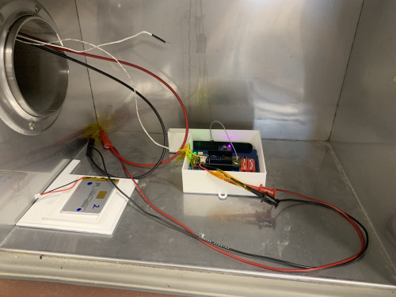

Figure 5